**ASSIGNMENT-11**

Create a VPC security group for a private DB instance

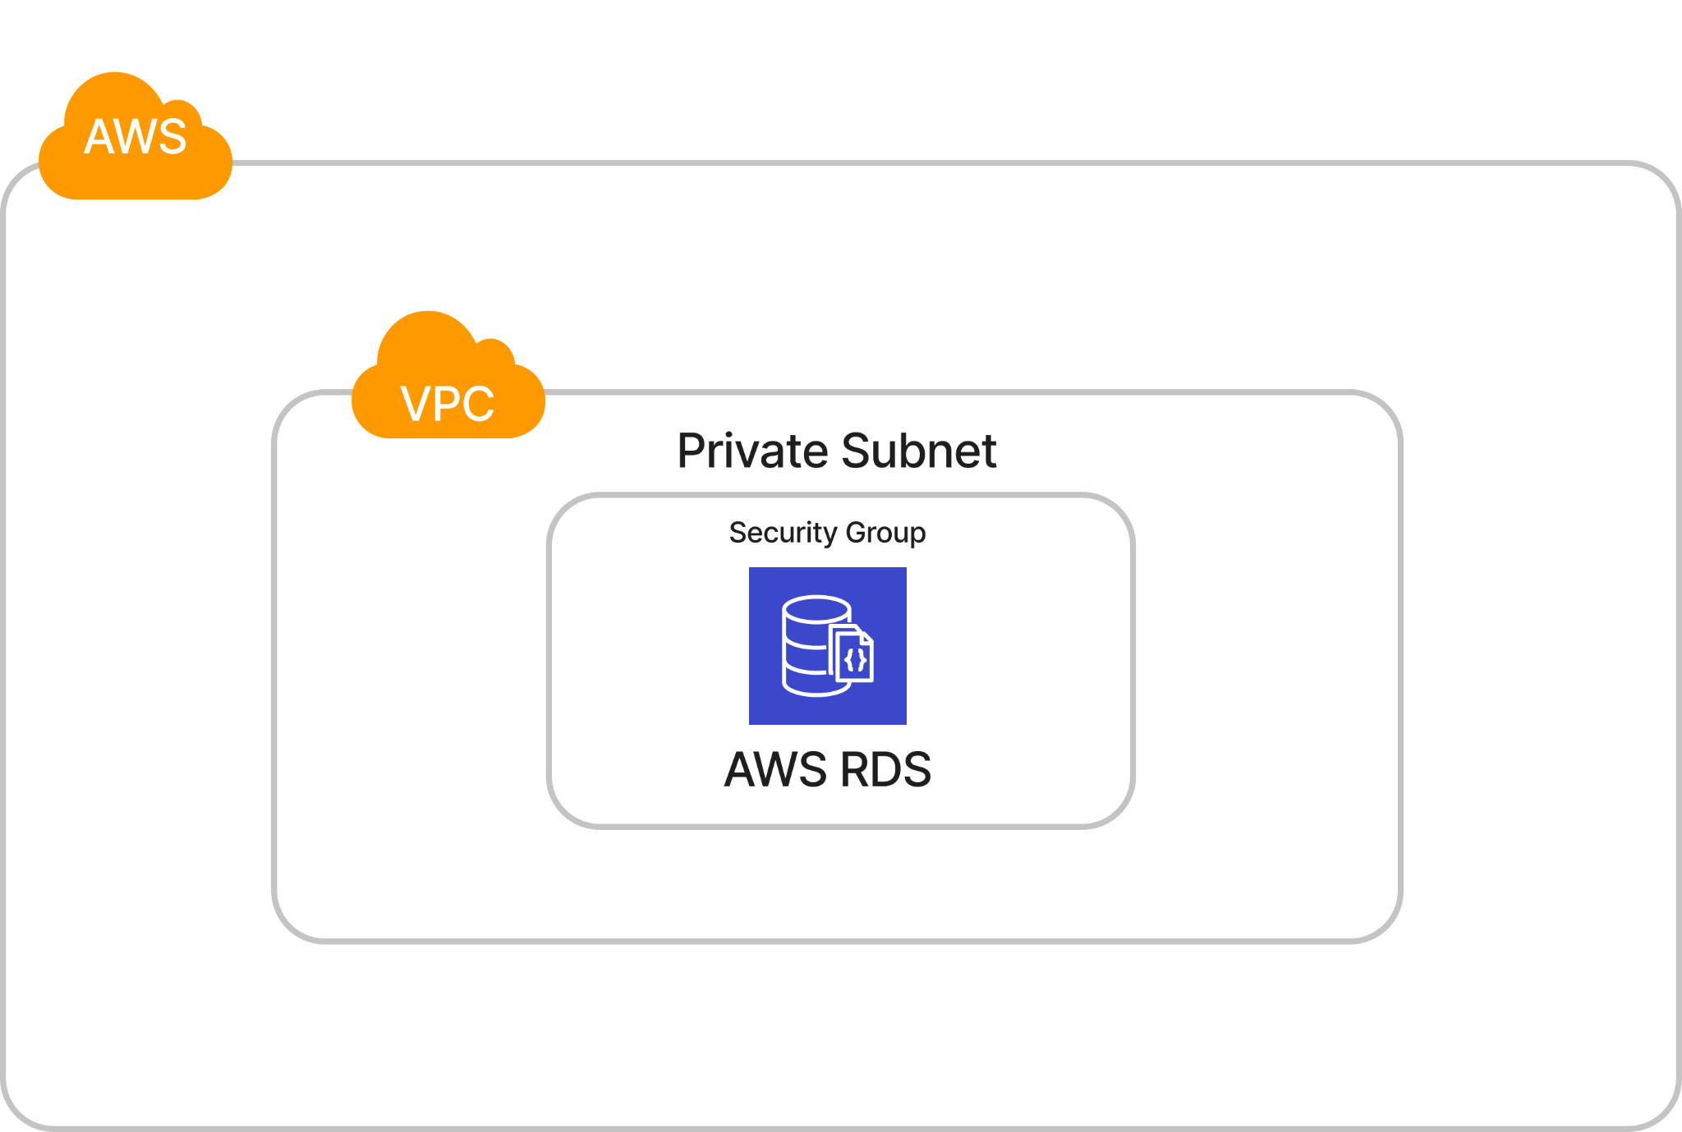

**Proof:**

**Creating RDS with a private Subnet to restrict access to the resources outside VPC.**

